ADVANCED JAVA

(CSN302)
Part of the degree of
BACHELOR OF TECHNOLOGY
COMPUTER SCIENCE AND ENGINEERING

Submitted to –
Mr. Piyush Anand
Submitted by:
Name- Tejaswi Sandilya, Nitesh Sharma,
Tanisha Bhandari, Dhanya Verma

SCHOOL OF COMPUTING

DIT UNIVERSITY, DEHRADUN

(State Private University through State Legislature Act No. 10 of 2013 of Uttarakhand and approved by UGC)
Mussoorie Diversion Road, Dehradun, Uttarakhand - 248009, India.

ACKNOWLEDGEMENT

We are sincerely grateful to all who have supported us in this project. First, we extend our heartfelt thanks to our project guide, Mr. Piyush Anand sir, for his invaluable guidance, dedication, and encouragement throughout this endeavor. His expertise and thoughtful insights were instrumental in shaping our progress.
We also thank each member of our team, whose hard work, collaboration, and commitment made this project possible. Your support has been invaluable, and we deeply appreciate your efforts.
Thank you all for helping make this project a success.

Question 1: Write a program in JAVA to create an Online Banking System.
Introduction
An Online Banking System is a software application that allows users to perform banking operations through a computer or mobile interface without visiting a physical bank.
It provides a secure way for customers to manage their accounts, transfer funds, check balances, and view transaction history.
This Java program represents a mini prototype of an online banking system using Swing (GUI) and Object-Oriented Programming (OOP).
It simulates how a real banking system works — user registration, login, deposit, withdraw, transfer, and viewing transactions.

Objective
The main objective of this system is to:
- Provide a simple and interactive banking interface.
- Allow users to register and create accounts.
- Let users log in and access personal banking features.
- Perform basic operations like deposit, withdraw, and transfer.
- Maintain a transaction history for each user.

Basic Working of the System
This online banking system follows a simple client-side workflow using GUI components.
1. User Registration
New users can create an account by entering:
- Username
- Password
The system saves these details in memory (using a HashMap) and initializes the balance to ₹0.
2. User Login
Existing users can log in by providing their username and password.
If credentials match, the user is taken to their Dashboard.
3. Dashboard Operations
Once logged in, users can:
- Deposit Money → Add amount to their balance.
- Withdraw Money → Remove amount (if sufficient balance exists).
- Transfer Money → Send money to another registered user.
- View Transaction History → See all activities (deposits, withdrawals, transfers).
Each operation updates the balance and records an entry in the user’s transaction history.
4. Logout
After completing transactions, the user can log out and return to the login screen.
Steps in Execution
- The system starts with the Login Screen.
- If the user doesn’t have an account → clicks Register.
- Fills in username and password → registration successful.
- Goes back to Login, enters credentials → access Dashboard.
- Performs Deposit, Withdraw, or Transfer operations.
- Checks Transaction History to review past actions.
- Finally, the user logs out safely.

Advantages
- Simple and easy to use.
- Demonstrates real banking operations conceptually.
- Works completely offline — no external dependencies.
- Helps beginners understand OOP + GUI + Event Handling in Java.
- Can be easily extended with more features like database or security.

Disadvantages
- Data is not saved permanently (erased when program closes).
- Passwords are stored as plain text (no encryption).
- Works only on the local computer, not truly online.
- Uses double for money (can cause rounding errors).
- No backend database or network connection.
- Not secure for real banking use — only educational.

CODE-
import javax.swing.*;
import java.awt.*;
import java.util.Map;
import java.util.HashMap;
import java.util.ArrayList;
import java.util.List;

// ===== MAIN CLASS =====
public class BankFrame extends JFrame {
Bank bank = new Bank();
User currentUser;

CardLayout layout = new CardLayout();
JPanel mainPanel = new JPanel(layout);
LoginPanel loginPanel;
RegisterPanel registerPanel;
DashboardPanel dashboardPanel;

public static void main(String[] args) {
new BankFrame();
}

BankFrame() {
setTitle("Online Banking System");
setSize(450, 400);
setDefaultCloseOperation(JFrame.EXIT_ON_CLOSE);
setLocationRelativeTo(null);

loginPanel = new LoginPanel(this);
registerPanel = new RegisterPanel(this);
dashboardPanel = new DashboardPanel(this);

mainPanel.add(loginPanel, "login");
mainPanel.add(registerPanel, "register");
mainPanel.add(dashboardPanel, "dashboard");

add(mainPanel);
layout.show(mainPanel, "login");
setVisible(true);
}

void showPanel(String name) {
layout.show(mainPanel, name);
}
}

// ===== BANK LOGIC =====
class Bank {
Map<String, User> users = new HashMap<>();

boolean register(String username, String password) {
if (users.containsKey(username)) return false;
users.put(username, new User(username, password));
return true;
}

User login(String username, String password) {
User u = users.get(username);
if (u != null && u.password.equals(password)) return u;
return null;
}

User findUser(String username) {
return users.get(username);
}
}

// ===== USER CLASS =====
class User {
String username;
String password;
double balance;
List<String> history = new ArrayList<>();

User(String u, String p) {
username = u;
password = p;
balance = 0.0;
}

void addHistory(String msg) {
history.add(msg);
}
}

// ===== LOGIN PANEL =====
class LoginPanel extends JPanel {
LoginPanel(BankFrame frame) {
setLayout(null); // Absolute positioning

JLabel title = new JLabel("Login");
title.setFont(new Font("Arial", Font.BOLD, 24));
title.setBounds(160, 30, 150, 30);
add(title);

JLabel userLabel = new JLabel("Username:");
userLabel.setBounds(80, 100, 80, 25);
add(userLabel);

JTextField userField = new JTextField();
userField.setBounds(180, 100, 150, 25);
add(userField);

JLabel passLabel = new JLabel("Password:");
passLabel.setBounds(80, 140, 80, 25);
add(passLabel);

JPasswordField passField = new JPasswordField();
passField.setBounds(180, 140, 150, 25);
add(passField);

JButton loginBtn = new JButton("Login");
loginBtn.setBounds(100, 200, 100, 30);
add(loginBtn);

JButton registerBtn = new JButton("Register");
registerBtn.setBounds(220, 200, 100, 30);
add(registerBtn);

loginBtn.addActionListener(e -> {
String user = userField.getText().trim();
String pass = new String(passField.getPassword());
User u = frame.bank.login(user, pass);
if (u != null) {
frame.currentUser = u;
JOptionPane.showMessageDialog(frame, "Welcome, " + user + "!");
frame.dashboardPanel.updateBalance();
frame.showPanel("dashboard");
} else {
JOptionPane.showMessageDialog(frame, "Invalid credentials!");
}
});

registerBtn.addActionListener(e -> frame.showPanel("register"));
}
}

// ===== REGISTER PANEL =====
class RegisterPanel extends JPanel {
RegisterPanel(BankFrame frame) {
setLayout(null); // Absolute positioning

JLabel title = new JLabel("Register New User");
title.setFont(new Font("Arial", Font.BOLD, 20));
title.setBounds(120, 30, 250, 30);
add(title);

JLabel userLabel = new JLabel("Username:");
userLabel.setBounds(80, 100, 80, 25);
add(userLabel);

JTextField userField = new JTextField();
userField.setBounds(180, 100, 150, 25);
add(userField);

JLabel passLabel = new JLabel("Password:");
passLabel.setBounds(80, 140, 80, 25);
add(passLabel);

JPasswordField passField = new JPasswordField();
passField.setBounds(180, 140, 150, 25);
add(passField);

JButton registerBtn = new JButton("Register");
registerBtn.setBounds(100, 200, 100, 30);
add(registerBtn);

JButton backBtn = new JButton("Back");
backBtn.setBounds(220, 200, 100, 30);
add(backBtn);

registerBtn.addActionListener(e -> {
String user = userField.getText().trim();
String pass = new String(passField.getPassword());
if (user.isEmpty() || pass.isEmpty()) {
JOptionPane.showMessageDialog(frame, "All fields required!");
return;
}
if (frame.bank.register(user, pass)) {
JOptionPane.showMessageDialog(frame, "User registered successfully!");
frame.showPanel("login");
} else {
JOptionPane.showMessageDialog(frame, "Username already exists!");
}
});

backBtn.addActionListener(e -> frame.showPanel("login"));
}
}

// ===== DASHBOARD PANEL =====
class DashboardPanel extends JPanel {
JLabel welcomeLabel = new JLabel("", SwingConstants.CENTER);
JLabel balanceLabel = new JLabel("", SwingConstants.CENTER);
JButton depositBtn = new JButton("Deposit");
JButton withdrawBtn = new JButton("Withdraw");
JButton transferBtn = new JButton("Transfer");
JButton historyBtn = new JButton("Transaction History");
JButton logoutBtn = new JButton("Logout");

BankFrame frame;

DashboardPanel(BankFrame frame) {
this.frame = frame;
setLayout(new GridLayout(7, 1, 10, 10));
setBorder(BorderFactory.createEmptyBorder(20, 20, 20, 20));

add(welcomeLabel);
add(balanceLabel);
add(depositBtn);
add(withdrawBtn);
add(transferBtn);
add(historyBtn);
add(logoutBtn);

depositBtn.addActionListener(e -> {
String amtStr = JOptionPane.showInputDialog(frame, "Enter amount to deposit:");
try {
double amt = Double.parseDouble(amtStr);
if (amt > 0) {
frame.currentUser.balance += amt;
frame.currentUser.addHistory("Deposited ₹" + amt);
updateBalance();
JOptionPane.showMessageDialog(frame, "Deposited ₹" + amt);
} else JOptionPane.showMessageDialog(frame, "Invalid amount!");
} catch (Exception ex) {
JOptionPane.showMessageDialog(frame, "Invalid input!");
}
});

withdrawBtn.addActionListener(e -> {
String amtStr = JOptionPane.showInputDialog(frame, "Enter amount to withdraw:");
try {
double amt = Double.parseDouble(amtStr);
if (amt > 0 && amt <= frame.currentUser.balance) {
frame.currentUser.balance -= amt;
frame.currentUser.addHistory("Withdrawn ₹" + amt);
updateBalance();
JOptionPane.showMessageDialog(frame, "Withdrawn ₹" + amt);
} else JOptionPane.showMessageDialog(frame, "Insufficient balance!");
} catch (Exception ex) {
JOptionPane.showMessageDialog(frame, "Invalid input!");
}
});

transferBtn.addActionListener(e ->{
String target = JOptionPane.showInputDialog(frame, "Enter receiver's username:");
if (target == null || target.isEmpty()) return;

User receiver = frame.bank.findUser(target);
if (receiver == null) {
JOptionPane.showMessageDialog(frame, "User not found!");
return;
}

String amtStr = JOptionPane.showInputDialog(frame, "Enter amount to transfer:");
try {
double amt = Double.parseDouble(amtStr);
if (amt > 0 && amt <= frame.currentUser.balance) {
frame.currentUser.balance -= amt;
receiver.balance += amt;
frame.currentUser.addHistory("Transferred ₹" + amt + " to " + target);
receiver.addHistory("Received ₹" + amt + " from " + frame.currentUser.username);
updateBalance();
JOptionPane.showMessageDialog(frame, "Transferred ₹" + amt + " to " + target);
} else JOptionPane.showMessageDialog(frame, "Invalid or insufficient balance!");
} catch (Exception ex) {
JOptionPane.showMessageDialog(frame, "Invalid input!");
}
});

historyBtn.addActionListener(e -> {
if (frame.currentUser.history.isEmpty()) {
JOptionPane.showMessageDialog(frame, "No transactions yet.");
return;
}
StringBuilder sb = new StringBuilder();
for (String t : frame.currentUser.history)
sb.append(t).append("\n");

JTextArea area = new JTextArea(sb.toString(), 15, 40);
area.setEditable(false);
JOptionPane.showMessageDialog(frame, new JScrollPane(area),
"Transaction History", JOptionPane.INFORMATION_MESSAGE);
});

logoutBtn.addActionListener(e -> {
frame.currentUser = null;
frame.showPanel("login");
});
}

void updateBalance() {
if (frame.currentUser != null) {
welcomeLabel.setText("Welcome, " + frame.currentUser.username);
balanceLabel.setText("Balance: ₹" + String.format("%.2f", frame.currentUser.balance));
}
}
}
OUTPUT-
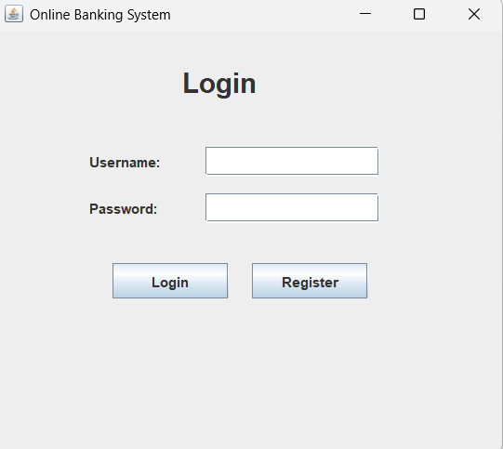
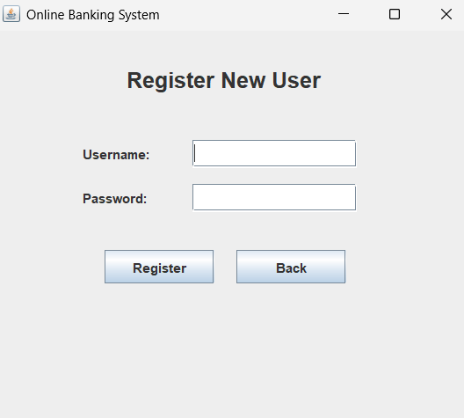
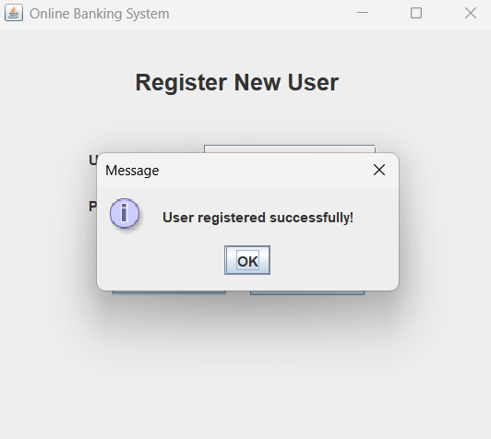
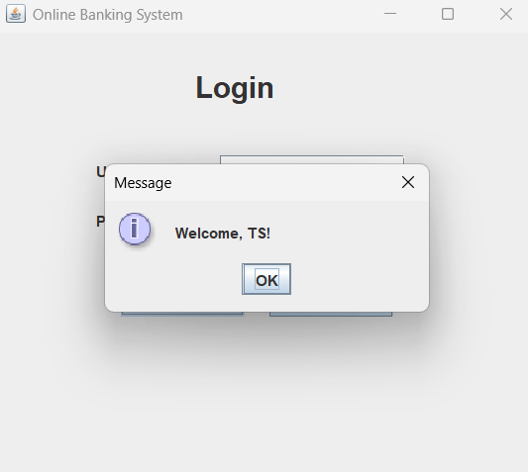
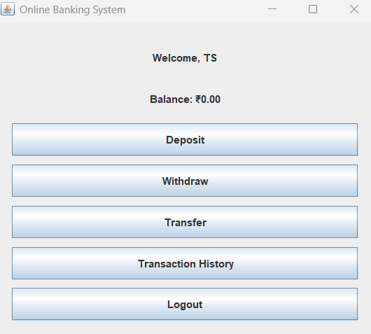
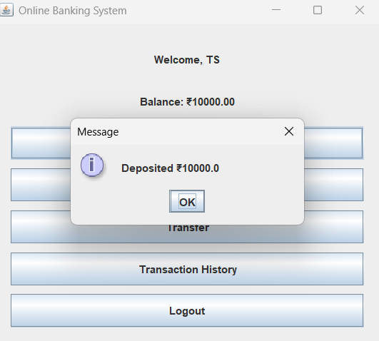
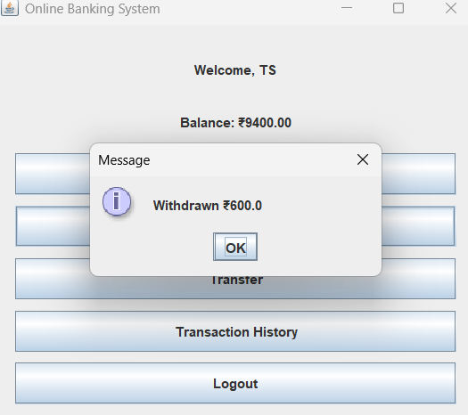
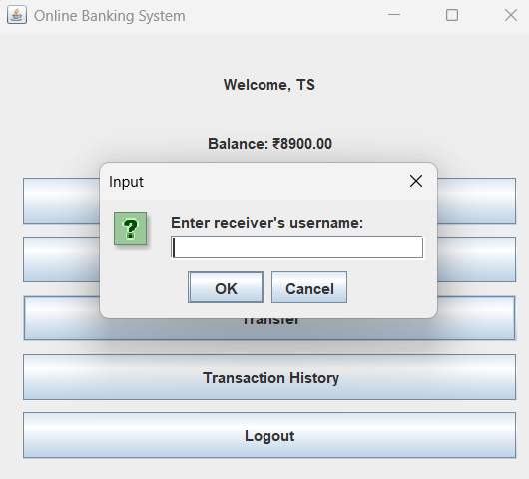
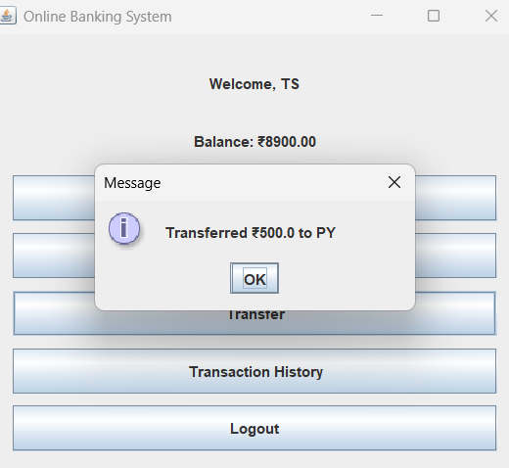
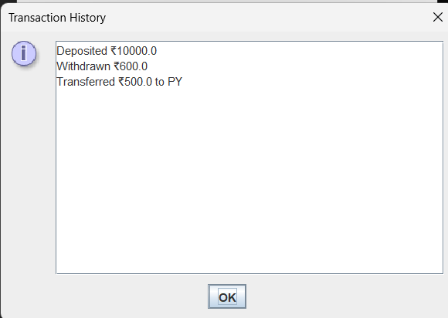

Bibliography
- Java Programming by Herbert Schildt, McGraw Hill Publication.
- Software Used: Java JDK 17, NetBeans IDE for program development.
- Operating System: Windows 10.
- Online Help: GeeksforGeeks and JavaTpoint websites for Java Swing and GUI concepts.

